**lsblk**

NAME MAJ:MIN RM SIZE RO TYPE MOUNTPOINTS

nvme0n1 259:0 0 10G 0 disk

├─nvme0n1p1 259:1 0 1M 0 part

├─nvme0n1p2 259:2 0 200M 0 part /boot/efi

├─nvme0n1p3 259:3 0 1G 0 part /boot

└─nvme0n1p4 259:4 0 8.8G 0 part /

This output represents the partition layout of a storage device (`nvme0n1`) on a Linux system. Let’s break it down step by step:

Key Components of the Output

**Device Name**

nvme0n1:

- This is the name of the NVMe disk (Non-Volatile Memory Express), which is a high-speed storage device commonly used in modern systems.

- `nvme0`: Refers to the first NVMe device.

- `n1`: Refers to the first namespace of the NVMe device (namespaces are logical divisions of NVMe storage).

MAJ:MIN

- 259:0 :

- These numbers represent the major and minor device numbers used by the kernel to identify the device uniquely.

- Major numbers refer to the driver managing the device, while minor numbers identify individual devices.

RM

- 0:

- Indicates whether the device is removable :

* `0`: Non-removable (e.g., internal storage like NVMe drives).
* `1`: Removable (e.g., USB drives).

SIZE

- 10G:

- The total size of the storage device is 10 GB .

RO

- `0`:

- Indicates whether the device is **read-only**:

- `0`: Read-write (can write to the device).

- `1`: Read-only (cannot write to the device).

TYPE

- disk:

- The type of device, which in this case is a disk.

MOUNTPOINTS

- Specifies where each partition is mounted in the Linux file system hierarchy.

**Partitions**

The device (`nvme0n1`) is divided into 4 partitions:

1. nvme0n1p1:

- Size: 1M (1 MB).

- Type: Partition.

- Purpose: Reserved space (often used for alignment or bootloader purposes in some setups).

- Mount Point : Not mounted.

2. nvme0n1p2:

- Size: 200M (200 MB).

- Type: Partition.

- Mount Point: /boot/efi.

- Purpose: This is the **EFI system partition (ESP)** , which stores the bootloader and other files needed for UEFI-based booting.

3. nvme0n1p3:

- Size : 1G (1 GB).

- Type : Partition.

- Mount Point : `/boot` .

- Purpose : Stores the Linux kernel , initramfs, and other boot-related files.

4. nvme0n1p4:

- Size: 8.8G (8.8 GB).

- Type : Partition.

- Mount Point : `/` (root).

- Purpose: The root filesystem , where the entire Linux operating system resides, including system files, libraries, user data, etc.

Overall Meaning

- nvme0n1` is a 10 GB NVMe storage device that has been partitioned into four parts:

1. A reserved partition (`nvme0n1p1`).

2. An EFI system partition (`nvme0n1p2`) for UEFI booting.

3. A boot partition (`nvme0n1p3`) for storing boot-related files.

4. A root partition (`nvme0n1p4`) where the Linux system is installed and running.

This partition layout is typical for systems using UEFI firmware, with the `/boot/efi` partition required for UEFI-based bootloaders like GRUB, and `/boot` and `/` handling the system files.

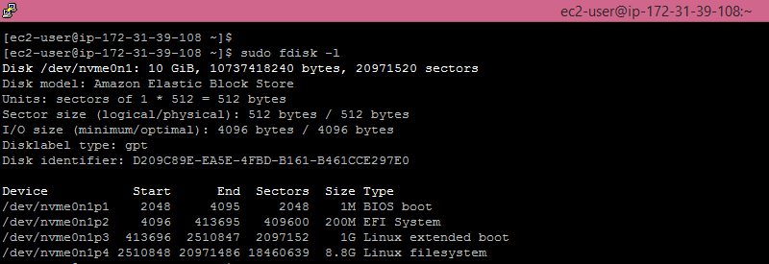

**Working with Hardware**

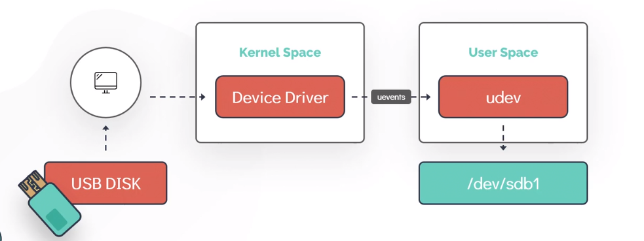

**dmesg** – This command gives us the detailed messages of devices/Operation that are being attached / happing in system

With dmesg we can use grep for text processing (Analyzing the message about particular devices)

**dmesg | grep –i usb**

**udevadm info** – Gives us the detailed information about the devices that are removed / Attached

**udevadm monitor** - This monitor gives us the received events for UDEV & KERNEL (events)

**lsblk** – gives us the block devices detailed

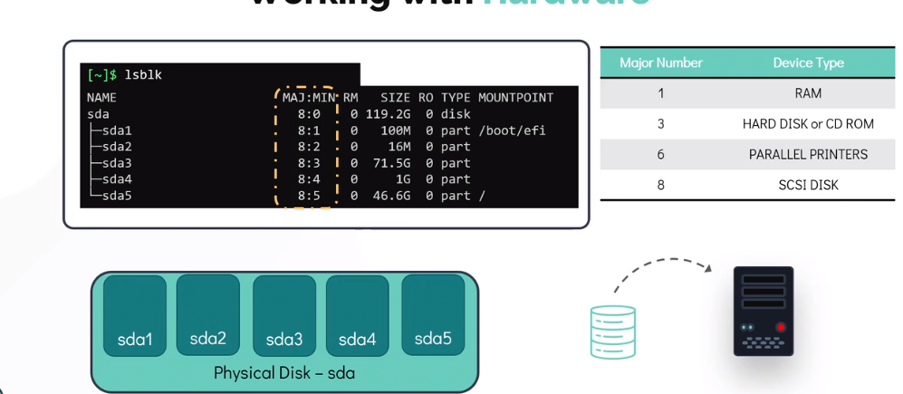

lspci – gives us the details about peripheral Component Interconnect devices

**PCI** is a **hardware interface standard** used to connect peripheral devices (like graphics cards, network cards, or storage devices) to a computer's motherboard.

There are some ports available in mother called PCI where all above devices are connected; to see the details of all above connected devices we can use lspci command

**Memory** – Memory Utilization in linux can be checked by following commends – lsmem/free –k/free –m/free -g

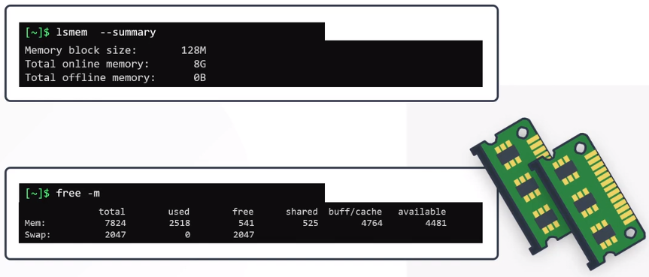

Detailed information of hardware configuration of linux system can be seeing by following shell commands – **lshw**

To see the detailed you must use superuser account / admin account